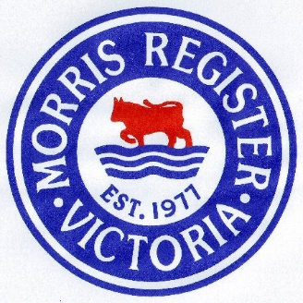
The Post-Lockdown Morris Register Urban Round-Up
Sunday 6th December 2020
We are allowed out, your Morris has been polished and serviced and you are itching for a good excuse to drive it. Well wait no more! Our first Post-Lockdown trip has been designed to give as many of our members a chance to catch up with the Register as possible. And to do this, we are holding a ‘round-trip’.
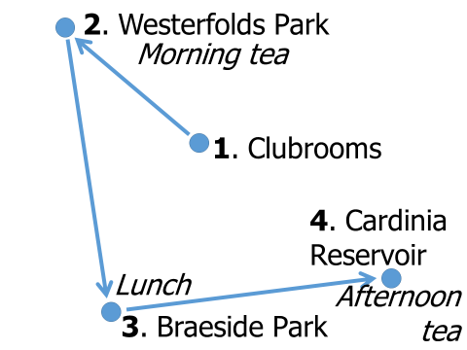
You are invited to start at the Club Rooms, meet us at any of the destinations or join us ‘en route’. Participate in as many legs as you like.
We will have marshals to welcome you at Braeside Park and Cardinia Reservoir as below:
Braeside Park:
Jennifer Jaeger: Ph: 0419 395 782
John Coles: Ph: 0408 050 756
They will arrive ahead of The Tour at around 10:30am if you wish to arrive a bit earlier.
Cardinia Reservoir Park:
Norm Stevens: Ph: 0417 194 615
Norm will arrive around 1:30pm for those might like to meet for a late lunch but before The Tour arrives.
At both Braeside Park and Cardinia Reservoir please look out for the club flag at or near the intended destination. We need to remain flexible as to the exact spot as we expect both these locations to be very busy if the weather is good. If in doubt please “Holler for a Marshall” on the above ‘phone numbers.
The Tour
At the risk of appearing boring, we have decided to stick to the major routes to keep the travelling simple and reasonably quick. A few Melways references (in italics) have been included just for safety.
Meet at Club Rooms at 9am
The event will kick-off at the Club Rooms at 9:00am for a 9:30am start. As we have a bit of ground to cover timing will be critical so if you are not there, we won’t wait.
First stop, a short drive to Westerfolds Park where we will meet at about 10:00 to 10:15am. Our route to Westerfolds Park will be:
Turn Rt on leaving the Club Rooms car park into Jolimont Road;
Turn Lt into Stevens Road
Turn Rt into Canterbury Road (Route 32)
Turn Lt into Mitcham Road (Route 36) – becomes Doncaster Road
Turn Rt into Blackburn Road (Route 13) (48 C1)
Turn Lt into Reynolds Road (Route 52) – becomes Foote Street (34 D6)
Turn Rt at RAB into Williamsons Road (Route 47)
Turn Lt into Porter Street at the big RAB with the ‘Apple peel’ sculpture.
Travel 200m west along Porter Street then turn Rt to directly reach entrance to Westerfolds Park (Melway 33 F3)
Drive in to Westerfolds Park about 700m to car park, shelter, tables and toilets.

Depart Westerfolds Park at 11:00am
Leave Westerfolds Park and turn Lt into Porter Street.
In 200m, turn Rt at the ‘Apple Peel RAB into Fitzsimons Lane (Route 47) – which becomes Williamsons Road.
Turn Lt into King Street (33 E8)
Turn Rt into Blackburn Road (Route 13) – becomes Surrey Road
Turn Rt into Whitehorse Road (Route 34), then almost immediately
Turn Lt into Chapel Street (Route 13) (48 A9)
At RAB take 1st exit Blackburn Road (Route 13)
Continue along Blackburn until the T-Juc at Princes Hwy (79 G1)
Turn Lt into Princes Hwy (Hwy 1), then shortly after
Turn Rt into Westall Road (Route 49)
Turn Rt into Springvale Road (Route 40) (88 J6)
Turn Rt into Governor Road (Route 12) and enter Braeside Park on your Right
We will park at the Redgum Picnic Area [Shelter, tables, toilets]

Depart Braeside Park at 1:30pm
Turn Lt into Governor Road (Route 12)
Turn Lt into Springvale Road (Route 40)
Turn Rt into Heatherton Road (Route 14) (88 K1)
Turn Lt into Belgrave-Hallam Road (C404) (108 F6)
At RAB take 3rd exit into Wellington Road (C413) (84 D10)
Turn Rt into Cardinia Creek Rd (Duffeys Road) (126 B11) and take left fork at Y-Jnc into Cardinia Reservoir Park,
Continue along Reservoir edge until sign to Kangaroo Flat and Crystal Brook Picnic Areas. There is a shelter at the Kangaroo Flat area but the toilets are at Crystal Brook. The toilets were closed when I visited due to a malfunction so I’m hoping they will be fixed by Dec 6th. Depending on the weather and/or crowds, Norm will have set-up camp at the most appropriate space.

Tour Ends
Stay as long as you like at Cardinia Reservoir.

